
WHIRLWINDS BASKETBALL CLUB

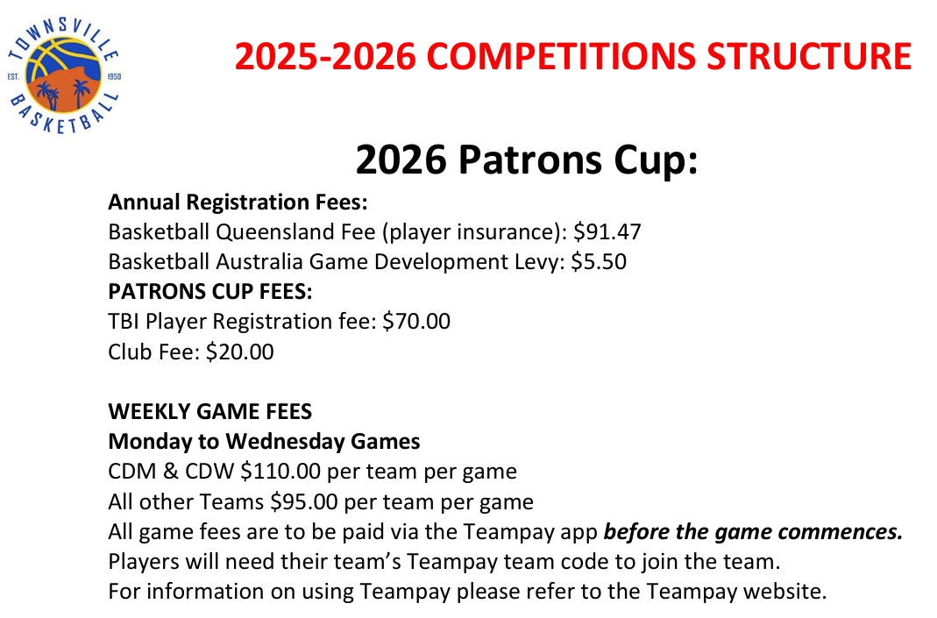

REGISTRATION
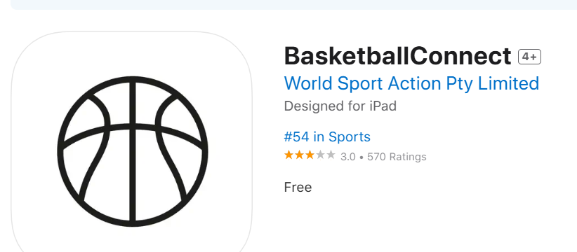
LINK on Basketball Connect APP



IN APP: 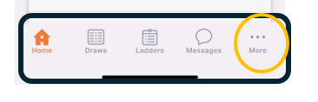 Click on ‘MORE’
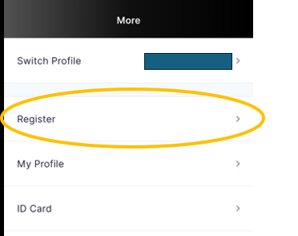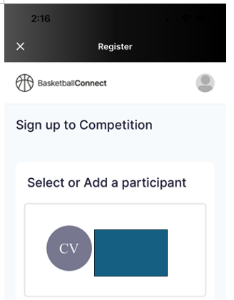
Click on Register. Click into ‘ participant’

Go through the Steps…..
Choose ‘Whirlwinds’
Choose ‘Patron’s Cup’

DATES of the PATRON’s CUP COMPETITION

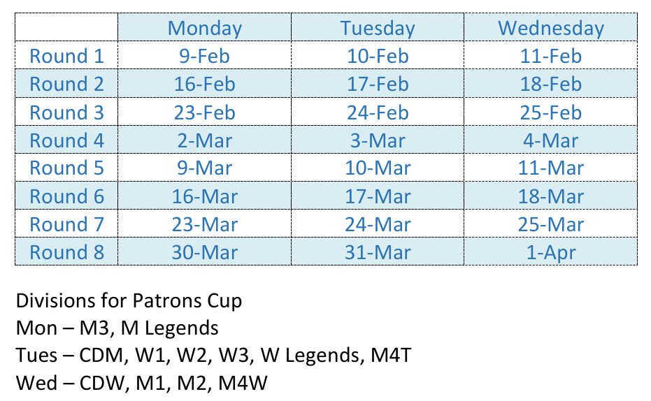

TEAM PAY RESOURCES 

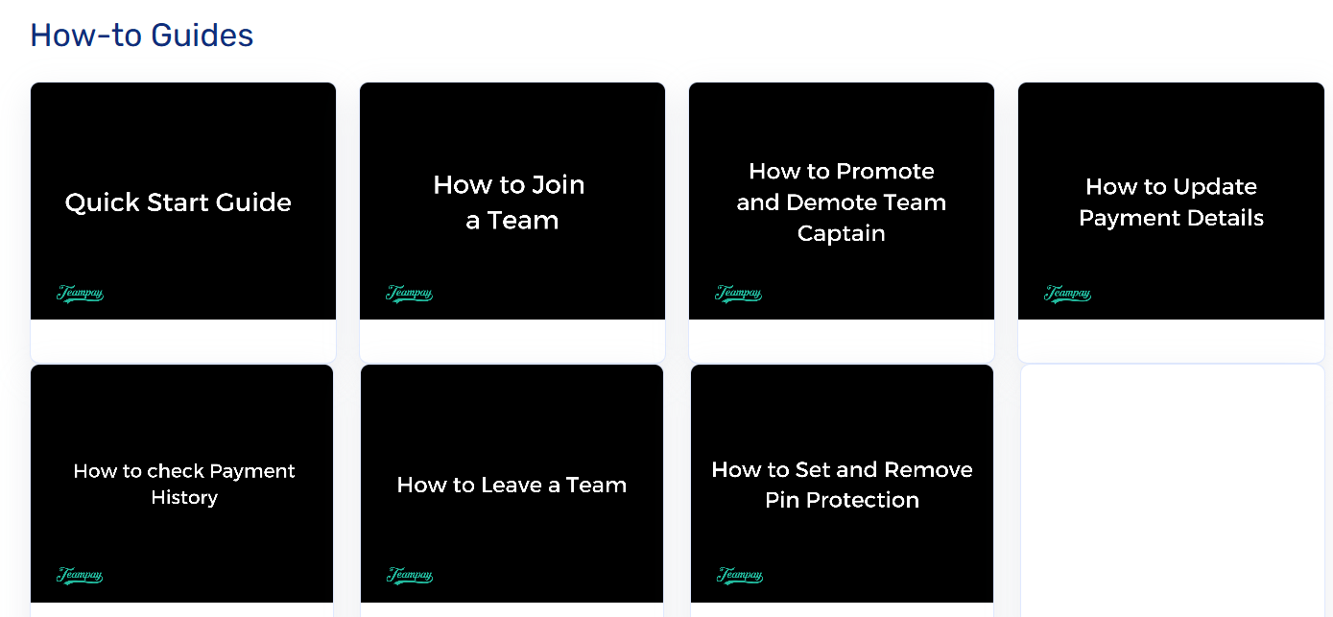

To keep updated with DRAW, COMMUNICATION – download Basketball Connect APP

This is the app system that Townsville Basketball will be using for the up and coming season.
It can be downloaded from the apple store or google play.


Whirlwinds Communication EMAIL for registrations:
whirlwindssenior@outlook.com
Whirlwinds Communication EMAIL for communication
whirlwindsbasketball@outlook.com

UNIFORM INFORMATION

For uniforms – playing singlets are provided by the coach. Families are required to purchase Whirlwinds Basketball playing shorts.

Link will give you access to purchase these items - https://hoop2hoop.com.au/clubs-associations/whirlwinds.html

